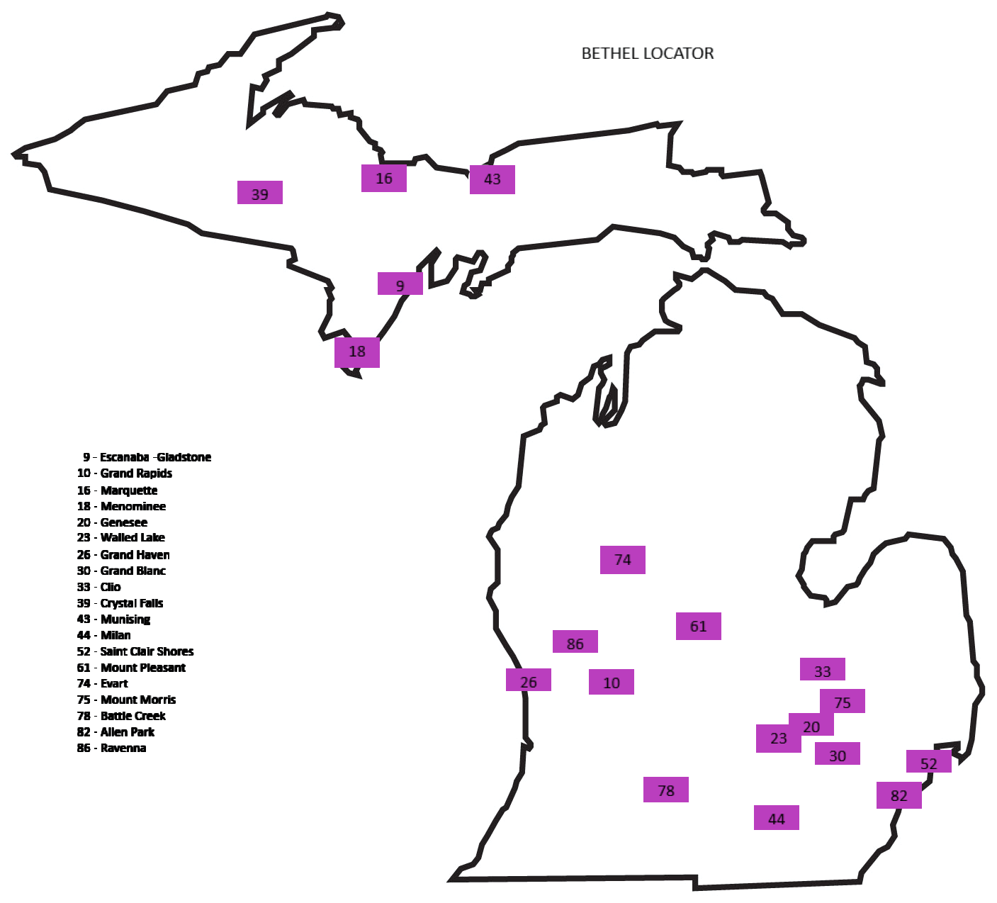
Michigan Job’s Daughters

# 9 Gladstone 2 & 4 Mondays 6:30 Masonic Temple 822-1/2 Delta Ave 49837
# 10 Grand Rapids 1 & 3 Mondays - 6:30 Masonic Temple 233 East Fulton 49503
# 16 Marquette 1 & 3 Thursdays 6:00 Masonic Temple 128 W. Washington 49855
# 18 Menominee 1 & 3 Mondays 7:00 CST Masonic Temple 430 10th Avenue 49858
# 20 Genesee 1 & 3 Thursdays 7:00 Masonic Temple 6208 N. Genesee Road 48506
# 23 Walled Lake 2 & 4 Mondays 7:15 Masonic Temple 374 W Walled Lake Drive 48390
# 26 Grand Haven 1 Mon & 3 Sat 7:00/1:00 Masonic Temple 344 Fulton 49417
# 30 Grand Blanc 2 & 4 Mondays 7:00 Masonic Temple 522 E. Grand Blanc 48439
# 33 Clio 1 & 3 Mondays 7:00 Masonic Temple 714 N. Mill Street 48420
# 39 Crystal Falls 2 & 4 Wednesdays 6:00 CST Masonic Temple 815 Crystal Avenue 49920
# 43 Munising 2 & 4 Tuesdays 7:00 Masonic Temple 228 W. Onota Street 49862
# 44 Milan 2 & 4 Tuesdays 7:00 Masonic Temple 37 Tolan Street 48160
# 52 St. Clair Shores 1 & 3 Tuesdays 7:00 Masonic Temple 22000 11 Mile Road 48081
# 61 Mt. Pleasant 1 & 3 Mondays 6:30 Masonic Temple 2174 S. Lincoln Road 48858​
# 74 Evart 1 & 3 Thursdays 6:30 Masonic Temple 301 S. Main 49631
# 75 Mt. Morris 2 & 4 Thursdays 7:00 Masonic Temple 810 North Street 48458​
​# 78 Battle Creek 2 & 4 Mondays 7:00 Masonic Temple 133 E. Michigan 49014
# 82 Allen Park 2 & 4 Wednesdays 7:00 Masonic Temple 17212 Ecorse Road 48101 ​
# 86 Ravenna 2 & 4 Saturdays 10:00 am Masonic Temple 345 Union Street 49345

